 | 20.4 Editors - NLA Editor - Footer tools and options
Table of content
Introduction 3
Playback Elements 3
Jump Time by Delta 3
Time Jump Delta 3
Jump Unit 3
Jump to Endpoint - start 3
Jump to Keyframe - previous 3
Play Animation - backward 3
Play Animation - forward 4
Jump to Keyframe - next 4
Jump to Endpoint - end 4
Cancel animation 4
Current Frame 4
Use Preview Range 4
Set Start Frame 4
Start 4
End 4
Set End Frame 4
Insert Keyframe 4
Delete Keyframe 5
Playhead Snapping 5
Snap Distance 5
Snap Target 5
Frames 5
Seconds 5
Markers 5
Keyframes 5
Strips 5
Frame Step 5
Second Step 6
Active Keying Set 6
Auto Keying 6
Auto Keyframing Popover 6
Auto keying mode 6
Add & Replace 6
Replace 6
Only Active Keying Set 6
Layered Recording 6
Cycle aware keying 6
Active Keying Set 7
Playback Panel 7
Audio 7
Sync Mode 7
No Sync 7
Frame Dropping 7
AV Sync 7
Scrubbing 7
Play Audio 8
Playback 8
Limit Playback to Frame Range 8
Follow Current Frame 8
Play in 8
Show Subframes 8
Keying Panel 8
New Keyframe Type 8
Auto Keyframing 9
Auto Keying Mode 9
Auto Keyframe Insert Keying Set 9
Layered Recording 9
Cycle Aware Keying 9
Options 9
Only show errors 9
Only show selected 9
Show Seconds 9
Sync visible range 9
Show Markers 10
Lock Markers 10
Show Cache 10
Softbody, Particles, etc. 10

Introduction

This chapter here is about the tools and options elements in the footer. It contains various elements and tools. This footer is shared across the animation editors. Dope Sheet, Graph Editor, Driver Editor and NLA Editor
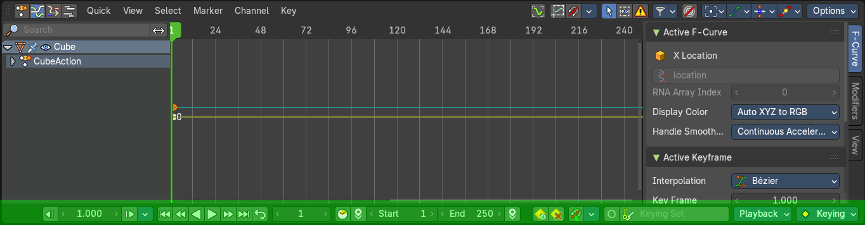

Playback Elements

The playback elements allows you to play your animation, and set the animation range.

Jump Time by Delta
Jump forward or backward by a given number of frames or seconds.

Time Jump Delta
The amount to step forward or backward.

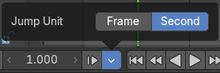
Jump Unit
The frame jump unit. Seconds or Frames.

Jump to Endpoint - start
Jumps to the first frame.

Jump to Keyframe - previous
Jumps to the keyframe before the current position.

Play Animation - backward
Plays the animation in reverse direction.

Play Animation - forward
Plays the animation.

Jump to Keyframe - next
Jumps to the keyframe after the current position.

Jump to Endpoint - end
Jumps to the last frame.

Cancel animation
Cancels the animation and returns to the original frame.

Current Frame
The edit box with the position of the current frame. Click at the value and type in another value to jump to another frame.

Use Preview Range
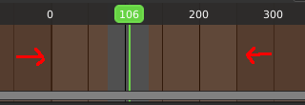
Toggle an alternative range used to preview animations. The Preview range works for the UI playback, but will not work for rendering an animation.
The preview range is displayed in orange color. The original playback range that is used for rendering is still displayed in grey underneath. When Use Preview Range is on, then the animation will loop between the Preview range.

Set Start Frame
Sets the current frame position as the start frame.

Start
The start frame for the animation in current mode.

End
The end frame for the animation in current mode.

Set End Frame
Sets the current frame position as the end frame.

Insert Keyframe
Inserts a keyframe. If you do not have a keying set assigned, this will default to the default keying set defined in the Preferences.

Delete Keyframe
Removes the keyframe at the current position in the current active keying set.

Playhead Snapping

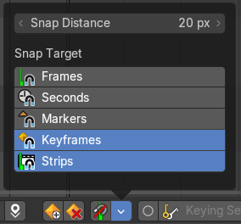
Playhead controls in animation editors help position the current frame indicator with precision, improving navigation and editing across the Timeline, Dope Sheet, Graph Editor, NLA, and Video Sequencer.

Snap Distance
Sets the snapping threshold in pixels. Determines how close the playhead must be to a target for snapping to occur.

Snap Target

Frames
Snaps to whole frame numbers. Ideal for frame-accurate editing instead of sub-frame cursor placement.

Seconds
Snaps to time intervals measured in seconds. Useful for audio syncing or time-based pacing.

Markers
Snaps to the closest timeline marker. Great for aligning actions to scene events or beats.

Keyframes
Snaps to keyframe positions. Ensures precise alignment for editing and playback.

Strips
Snaps to the start or end of video/audio strips. Useful in the Video Sequencer and NLA editor.

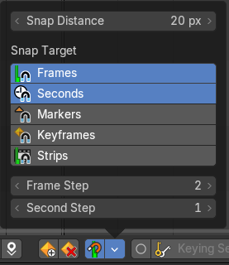
Frame Step
Defines the step size for frame-by-frame navigation. Controls how far the playhead moves when stepping through frames manually.
Note: Only available with Frames Snap Target

Second Step
Defines the step size for second-by-second navigation. Controls how far the playhead moves when stepping through the timeline manually.
Note: Only available with Second Snap Target

Active Keying Set
Objects needs a so called keying set so that you can record animation for it. It is a container for the animation, a set of keyframe channels. When you try to record an animation without an existing keying set, then you will get a warning since the channels for the keyframes are missing.
In this property you can choose a method from the builtin keying sets.

Auto Keying
With auto keying on every manipulation in the 3d view will automatically create a keyframe, or update the existing keyframe at the current position.
Note that Auto Keying just works with transform properties ( Objects and Bones) in the 3d View. It will not work to animate colors in the Properties Editor for example.

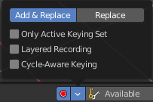
Auto Keyframing Popover
Auto keying settings. These settings shows when you have auto keying activated.

Auto keying mode

Add & Replace
Replace existing keyframes and add new ones where no keyframes exists.

Replace
Just replace existing keyframes.

Only Active Keying Set
Automatic keyframe insertion using active keying set only.

Layered Recording
Add a new nla track and strip for every loop or pass made over the animation. This allows non destructive tweaking.

Cycle aware keying
For channels with cyclic extrapolation, the keyframe insertion is automatically remapped inside the cycle time range, and keeps the ends in sync.

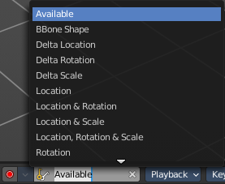
Active Keying Set
Choose your keying set.

Playback Panel
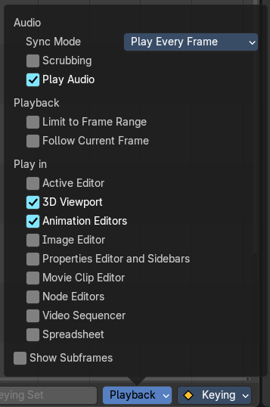
Here you can find various options for playback.

Audio

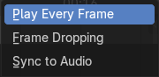
Sync Mode
How to synchronize playback.

No Sync
Don't synchronize. Play every frame.

Frame Dropping
Drop frames if playback is too slow.

AV Sync
Drop frames to synchronize to Audio Playback.

Scrubbing
Play existing audio from sequence editor when scrubbing.

Play Audio
Play back existing audio from sequence editor, otherwise mute the audio when deactivated. Use the Sequence Editor to add audio.

Playback

Limit Playback to Frame Range
Don't allow frame selection with the mouse outside of the play range.

Follow Current Frame
Follow current frame in editors.

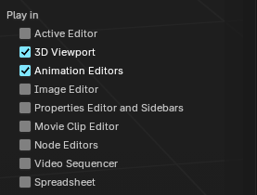
Play in
Plays the animation in the chosen editor types.
- Active Editor
- 3D Viewport
- Animation Editors
- Image Editor
- Properties Editor and Sidebars
- Movie Clip Editor
- Node Editors
- Video Sequencer
- Spreadsheet

Show Subframes
Display and allow setting fractional frame values for the current frame.

Keying Panel

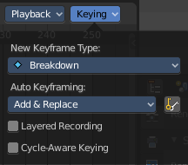
Some more keying options.

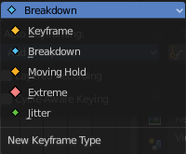
New Keyframe Type
Recolor the currently selected keyframes. Or create the next keyframe with this chosen keyframe color.

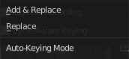
Auto Keyframing

Auto Keying Mode
Just replace existing keyframes, or add keyframes too.

Auto Keyframe Insert Keying Set
Automatic Keyframe Insertion using the active keying set only.

Layered Recording
Add a new NLA Track and Strip for every loop/ pass made over the animation to allow non destructive tweaking.

Cycle Aware Keying
For channels with cyclic extrapolation, keyframe insertion is automatically remapped inside the cycle time range, and keeps the ends in sync.

Options

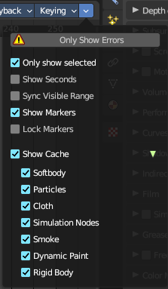

Only show errors
Only include f-curves that are disabled or have errors.

Only show selected
Just show the keyframes from the selected object.

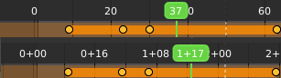
Show Seconds
Show the timing in the timeline area in seconds instead of frames.

Sync visible range
Synchronize the visible timeline range with other visible time based editors. When you zoom in or out in the one editor, then it zooms in or out in the other editor too. Each editor to sync needs to have Sync Visible Range ticked.

Show Markers
Display the markers row at the bottom of the view.

Lock Markers
Make the markers uneditable.

Show Cache
Show animation information for cached objects like Particles.

Softbody, Particles, etc.
Include or exclude what kind of cache types you want to display.

